

Project Name

Project Group Members: Shane Martin, Zoshua Colah, Yiran Ni, Jojo Saunders

INFO 200 | Section Name | TA Name

Table of Contents

**Solutions Considered** **2**

Solution 1 (~100-150 words) 2

Solution 2 (~100-150 words) 3

Solution 3 (~100-150 words) 3

Solution 4 (~100-150 words) 3

**Selected Solution (~200 words)** **4**

**Description of Your Solution (~200 words)** **4**

Product Features 5

Primary Features 5

Secondary Features 5

SiteMap (optional to include) 6

Low Fidelity Wireframes 7

Brainstorming Stage 7

Final Low-Fidelity Wireframes 7

Onboarding Screen / Screen 1 8

Home Screen / Screen 2 9

Categories Screen / Screen 3 10

Home Screen (website wireframe example) / Screen 4 11

**Usage Scenarios (~200 words each)** **12**

Usage Scenario 1: Ordering an Uber X Taxi to Fremont Troll 12

Usage Scenario 2: Scheduling an Uber XL Taxi to the Airport 12

User Journey Map (Optional to include) 13

**Bibliography** **14**

**Appendix** **14**

The Project Draft Design document is the start of your final project document which you will submit at the end of this class. It is a culmination of all your project deliverables. By the end of creating this document, you should have a portfolio piece ready which you can add to your website and LinkedIn. The project draft design takes a lot of time to put together so I highly suggest getting started now.

Below I have listed all the elements of the Project Design Draft which should be present in the document. I have provided a step by step walkthrough of how you should go ahead so as to help your project go smoothly. Please take 15 minutes out and read through it carefully.

You should already have these ready from the past few project deliverable you have completed. You may need to make small updates but that is it.

* Cover Page: Team logo, project brief, team member names.
* Team Members: Include a short brief about each member’s responsibilities.
* Introduction: Write an introduction to your project. What is the information problem? What are the key problems you are trying to solve?
* User Research *(Optional to include)*: What research methods did you use? What were your findings? Provide a link to your survey if you conducted any. If you have additional research notes add it to the appendix.
* Personas *(Optional to include)*: Justify your personas. Who was your main focus? Are there any additional personas?

# Solutions Considered

Consider the different solutions you could create for your solution. You could create a website, app, service, infographic, data visualization, information pamphlet, a comic, etc. You could even make a physical object.

Describe each solution you considered. State the advantages and disadvantages of each.

## Solution 1 (~100-150 words)

Lorem ipsum dolor sit amet, consectetur adipiscing elit. In posuere lacus arcu, vitae convallis dolor dignissim ut. Vivamus euismod massa semper mi molestie placerat. Cras quis diam facilisis, venenatis tortor ac, pulvinar lorem. Vestibulum placerat arcu eu tortor consectetur, eu auctor dui tempor. Mauris eu justo non mi condimentum mollis et in elit. Integer condimentum orci quis libero mollis porttitor. Nulla varius lacus risus, id iaculis metus facilisis et. Class aptent taciti sociosqu ad litora torquent per conubia nostra, per inceptos himenaeos. Duis rutrum pretium magna nec sollicitudin. Aliquam molestie vehicula erat, vel tempus sem volutpat et. Donec diam urna.

## Solution 2 (~100-150 words)

Lorem ipsum dolor sit amet, consectetur adipiscing elit. In posuere lacus arcu, vitae convallis dolor dignissim ut. Vivamus euismod massa semper mi molestie placerat. Cras quis diam facilisis, venenatis tortor ac, pulvinar lorem. Vestibulum placerat arcu eu tortor consectetur, eu auctor dui tempor. Mauris eu justo non mi condimentum mollis et in elit. Integer condimentum orci quis libero mollis porttitor. Nulla varius lacus risus, id iaculis metus facilisis et. Class aptent taciti sociosqu ad litora torquent per conubia nostra, per inceptos himenaeos. Duis rutrum pretium magna nec sollicitudin. Aliquam molestie vehicula erat, vel tempus sem volutpat et. Donec diam urna.

## Solution 3 (~100-150 words)

Lorem ipsum dolor sit amet, consectetur adipiscing elit. In posuere lacus arcu, vitae convallis dolor dignissim ut. Vivamus euismod massa semper mi molestie placerat. Cras quis diam facilisis, venenatis tortor ac, pulvinar lorem. Vestibulum placerat arcu eu tortor consectetur, eu auctor dui tempor. Mauris eu justo non mi condimentum mollis et in elit. Integer condimentum orci quis libero mollis porttitor. Nulla varius lacus risus, id iaculis metus facilisis et. Class aptent taciti sociosqu ad litora torquent per conubia nostra, per inceptos himenaeos. Duis rutrum pretium magna nec sollicitudin. Aliquam molestie vehicula erat, vel tempus sem volutpat et. Donec diam urna.

## Solution 4 (~100-150 words)

Lorem ipsum dolor sit amet, consectetur adipiscing elit. In posuere lacus arcu, vitae convallis dolor dignissim ut. Vivamus euismod massa semper mi molestie placerat. Cras quis diam facilisis, venenatis tortor ac, pulvinar lorem. Vestibulum placerat arcu eu tortor consectetur, eu auctor dui tempor. Mauris eu justo non mi condimentum mollis et in elit. Integer condimentum orci quis libero mollis porttitor. Nulla varius lacus risus, id iaculis metus facilisis et. Class aptent taciti sociosqu ad litora torquent per conubia nostra, per inceptos himenaeos. Duis rutrum pretium magna nec sollicitudin. Aliquam molestie vehicula erat, vel tempus sem volutpat et. Donec diam urna.

Feel free to also present the solutions considered in a table.

|  |  |  |  |  |
| --- | --- | --- | --- | --- |
|  | Solution 1 | Solution 2 | Solution 3 | Solution 4 |
| Description |  |  |  |  |
| Advantages |  |  |  |  |
| Disadvantages |  |  |  |  |

# 

# Selected Solution (~200 words)

Select the most appropriate solution for your stakeholders.

* State why you selected that solution.
* What were the advantages of it over the rest?
* What made it stand out as the best solution?

Lorem ipsum dolor sit amet, consectetur adipiscing elit. Morbi quis tincidunt libero. Duis suscipit erat eleifend ex pulvinar tempus. Cras placerat quam in rutrum dapibus. In massa lacus, molestie euismod luctus vitae, pharetra in mi. Sed tristique ex nibh, aliquam finibus arcu lacinia et. Donec magna mauris, facilisis sit amet augue ut, venenatis blandit sem. Donec enim nisi, euismod ac tincidunt sit amet, lobortis non tortor. Integer fringilla, arcu id rutrum facilisis, elit lectus porta ligula, pretium eleifend dui justo et mi. Sed vulputate viverra nunc, ut viverra massa accumsan vel. Nulla lectus elit, pulvinar ultricies facilisis vel, faucibus non justo. Lorem ipsum dolor sit amet, consectetur adipiscing elit.

Vestibulum id nulla sodales, fermentum purus vel, luctus mauris. Donec nec tincidunt erat, quis gravida justo. Orci varius natoque penatibus et magnis dis parturient montes, nascetur ridiculus mus. Donec facilisis mollis urna, ut volutpat lorem placerat eu. Sed efficitur feugiat lorem, ac mattis nulla posuere vitae. Morbi felis justo, fringilla ac pretium a, tincidunt at tellus. Vivamus risus nisl, maximus quis varius id, rhoncus ut turpis.

# Description of Your Solution (~200 words)

Spend some time as a group brainstorming what you imagine the solution to look like. Here are some great articles to help you with brainstorming some ideas:

* [The Framework for Brainstorming Anything](https://blog.ajsmart.com/the-framework-for-brainstorming-anything-69371eb6f9ac)
* [Visual Thinking in Generating Ideas](https://medium.com/sketchit/visual-thinking-in-generating-ideas-five-simple-steps-a9fda12c4614)
* [UX Brainstorming Exercise  -  The 4x4](https://medium.com/@andreifrincu/ux-brainstorming-exercise-the-4-4-d0a4b8bea40f)
* [Learn How to Use the Best Ideation Methods](https://www.interaction-design.org/literature/article/learn-how-to-use-the-best-ideation-methods-brainstorming-braindumping-brainwriting-and-brainwalking)
* If you can, try and share pictures from your brainstorming process (e.g. whiteboards/ initial sketches)

Lorem ipsum dolor sit amet, consectetur adipiscing elit. Morbi quis tincidunt libero. Duis suscipit erat eleifend ex pulvinar tempus. Cras placerat quam in rutrum dapibus. In massa lacus, molestie euismod luctus vitae, pharetra in mi. Sed tristique ex nibh, aliquam finibus arcu lacinia et. Donec magna mauris, facilisis sit amet augue ut, venenatis blandit sem. Donec enim nisi, euismod ac tincidunt sit amet, lobortis non tortor. Integer fringilla, arcu id rutrum facilisis, elit lectus porta ligula, pretium eleifend dui justo et mi. Sed vulputate viverra nunc, ut viverra massa accumsan vel. Nulla lectus elit, pulvinar ultricies facilisis vel, faucibus non justo. Lorem ipsum dolor sit amet, consectetur adipiscing elit.

Vestibulum id nulla sodales, fermentum purus vel, luctus mauris. Donec nec tincidunt erat, quis gravida justo. Orci varius natoque penatibus et magnis dis parturient montes, nascetur ridiculus mus. Donec facilisis mollis urna, ut volutpat lorem placerat eu. Sed efficitur feugiat lorem, ac mattis nulla posuere vitae. Morbi felis justo, fringilla ac pretium a, tincidunt at tellus. Vivamus risus nisl, maximus quis varius id, rhoncus ut turpis.

## Product Features

Create a list of functions and features your solution will have.

* State how these functions and features will help benefit your user and help solve the information problem.
* Focus on your most valuable feature/function first and add your secondary functions with time.

### Primary Features

Feature 1: Donec nec tincidunt erat, quis gravida justo. Orci varius natoque penatibus et magnis dis parturient montes, nascetur ridiculus mus. Donec facilisis mollis urna, ut volutpat lorem placerat eu. Sed efficitur feugiat lorem, ac mattis nulla posuere vitae. Morbi felis justo, fringilla ac pretium a, tincidunt at tellus. Vivamus risus nisl, maximus quis varius id, rhoncus ut turpis.

Feature 2: Donec nec tincidunt erat, quis gravida justo. Orci varius natoque penatibus et magnis dis parturient montes, nascetur ridiculus mus. Donec facilisis mollis urna, ut volutpat lorem placerat eu. Sed efficitur feugiat lorem, ac mattis nulla posuere vitae. Morbi felis justo, fringilla ac pretium a, tincidunt at tellus. Vivamus risus nisl, maximus quis varius id, rhoncus ut turpis.

### Secondary Features

Feature Name: Donec nec tincidunt erat, quis gravida justo. Orci varius natoque penatibus et magnis dis parturient montes, nascetur ridiculus mus. Donec facilisis mollis urna, ut volutpat lorem placerat eu. Sed efficitur feugiat lorem, ac mattis nulla posuere vitae.

Feature Name: Donec nec tincidunt erat, quis gravida justo. Orci varius natoque penatibus et magnis dis parturient montes, nascetur ridiculus mus. Donec facilisis mollis urna, ut volutpat lorem placerat eu. Sed efficitur feugiat lorem, ac mattis nulla posuere vitae.

Feature Name: Donec nec tincidunt erat, quis gravida justo. Orci varius natoque penatibus et magnis dis parturient montes, nascetur ridiculus mus. Donec facilisis mollis urna, ut volutpat lorem placerat eu. Sed efficitur feugiat lorem, ac mattis nulla posuere vitae.

## 

## SiteMap (optional to include)

Sitemaps are a hierarchical diagram showing the structure of a website or application. Some students in the past have included sitemaps as part of their draft design as it helps them organize the different steps to use their solution and think through how a user would use their application or website or software. You can include a sitemap as well.

Why should I use a sitemap?

1. They show how the navigation should be structured
2. They help identify where content will sit and what needs to be produced
3. They help show the relationship between different pages

You can use a tool like Powerpoint or [lucidchart.com](http://lucidchart.com) to make a sitemap.

Below is an example of a sitemap for a website which allows people to donate to different charity organizations. Your sitemap does not need to be as elaborate as this.

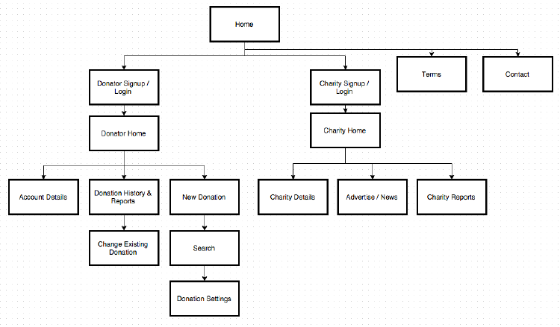

## 

## Low Fidelity Wireframes

Before you get started at this stage I would highly recommend doing the following:

* [Read goodui.org.](https://goodui.org/)
  + They have important design insights which will help you design your solution.
* [Read through this short document on good UX practices.](https://drive.google.com/file/d/0Bwc1bjS476HdOGhjeW9lM0Jfdzg/view)
* Read up on [design psychology](https://uxlibrary.gitbook.io/resources/ux-readings/design-psychology) and [design principles](https://uxlibrary.gitbook.io/resources/ux-readings/design-principles)

### Brainstorming Stage

We highly recommend that you first sketch out low fidelity wireframes as it helps you brainstorm and think of different ideas. Tell us and show us your design process. Remember to take pictures of your sketches.

* We would recommend doing the rapid prototyping exercise we did in class to help churn out ideas.
* Make multiple versions through your prototyping stage. Try out different layouts and different button placements. This is the perfect chance to do so. Show us the different versions you made.

We recommend that you reach out to your TA and ask them to review your wireframes and provide you with feedback. This will help you improve your final low-fidelity wireframes and ensure any errors are identified.

### Final Low-Fidelity Wireframes

When it comes to showing us your final low-fidelity wireframes, we'd like you to show us the main "flow" of your application. Show us how each wireframe connects to each other and what features and functions each of those screens have. This is your way to show us the main screens that will be a part of your solution so we can understand it visually.

1. Show us your finalized sketches and wireframes. These can be on paper or made on [Balsamiq.com](http://balsamiq.com)
2. Annotate or caption your wireframes. Explain the rationale behind your design decisions in your annotations. We will cut points if a rationale or annotations are missing.

Below we have given examples of previous student submissions.

#### 

#### Onboarding Screen / Screen 1

Donec nec tincidunt erat, quis gravida justo. Orci varius natoque penatibus et magnis dis parturient montes, nascetur ridiculus mus. Donec facilisis mollis urna, ut volutpat lorem placerat eu. Sed efficitur feugiat lorem, ac mattis nulla posuere vitae. Morbi felis justo, fringilla ac pretium a, tincidunt at tellus. Vivamus risus nisl, maximus quis varius id, rhoncus ut turpis.

Donec nec tincidunt erat, quis gravida justo. Orci varius natoque penatibus et magnis dis parturient montes, nascetur ridiculus mus. Donec facilisis mollis urna, ut volutpat lorem placerat eu. Sed efficitur feugiat lorem, ac mattis nulla posuere vitae. Morbi felis justo, fringilla ac pretium a, tincidunt at tellus. Vivamus risus nisl, maximus quis varius id, rhoncus ut turpis.

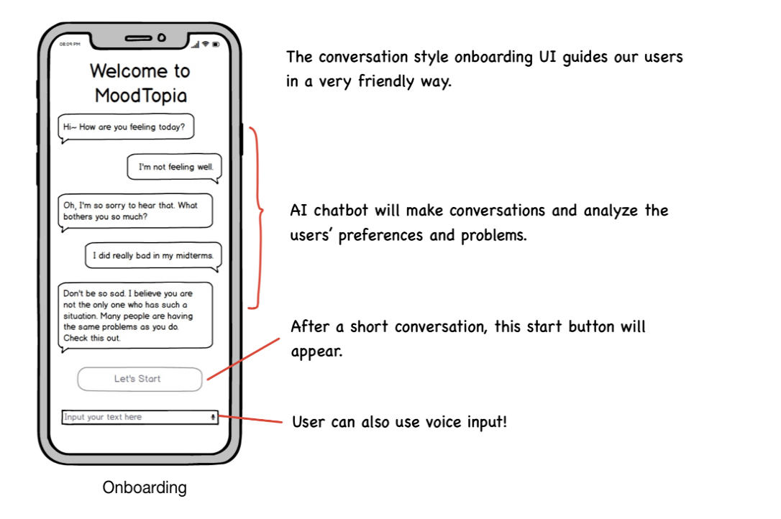

#### 

#### Home Screen / Screen 2

Donec nec tincidunt erat, quis gravida justo. Orci varius natoque penatibus et magnis dis parturient montes, nascetur ridiculus mus. Donec facilisis mollis urna, ut volutpat lorem placerat eu. Sed efficitur feugiat lorem, ac mattis nulla posuere vitae. Morbi felis justo, fringilla ac pretium a, tincidunt at tellus. Vivamus risus nisl, maximus quis varius id, rhoncus ut turpis.

Donec nec tincidunt erat, quis gravida justo. Orci varius natoque penatibus et magnis dis parturient montes, nascetur ridiculus mus. Donec facilisis mollis urna, ut volutpat lorem placerat eu. Sed efficitur feugiat lorem, ac mattis nulla posuere vitae. Morbi felis justo, fringilla ac pretium a, tincidunt at tellus. Vivamus risus nisl, maximus quis varius id, rhoncus ut turpis.

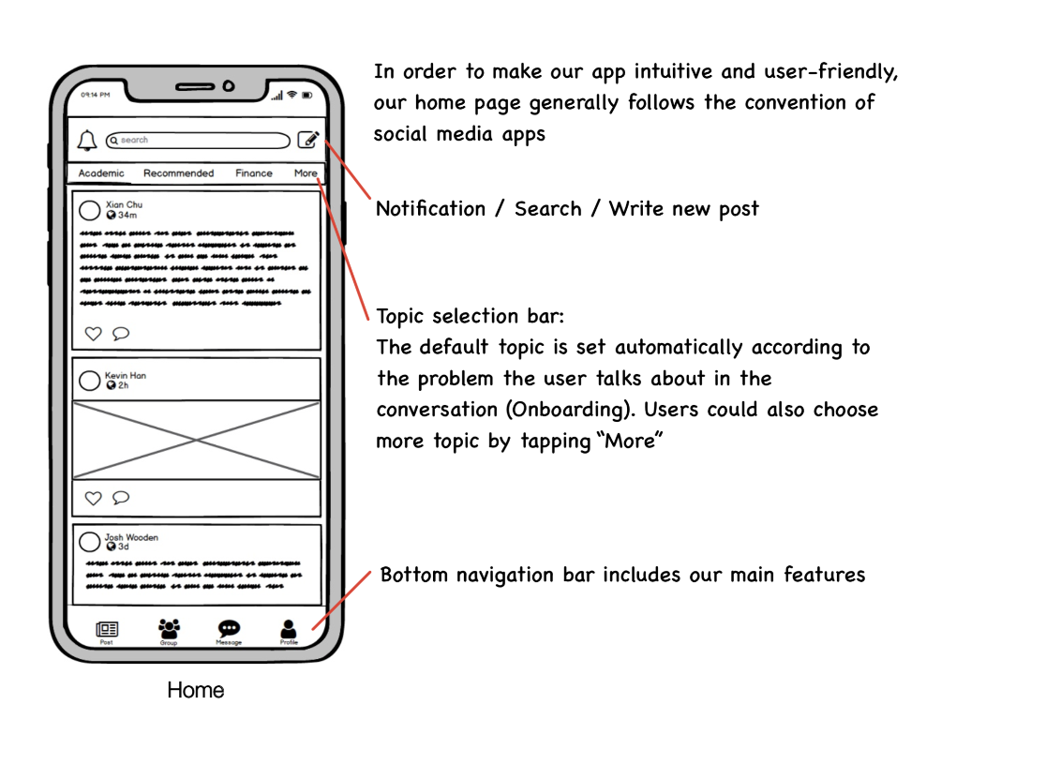

#### 

#### Categories Screen / Screen 3

Donec nec tincidunt erat, quis gravida justo. Orci varius natoque penatibus et magnis dis parturient montes, nascetur ridiculus mus. Donec facilisis mollis urna, ut volutpat lorem placerat eu. Sed efficitur feugiat lorem, ac mattis nulla posuere vitae. Morbi felis justo, fringilla ac pretium a, tincidunt at tellus. Vivamus risus nisl, maximus quis varius id, rhoncus ut turpis.

Donec nec tincidunt erat, quis gravida justo. Orci varius natoque penatibus et magnis dis parturient montes, nascetur ridiculus mus. Donec facilisis mollis urna, ut volutpat lorem placerat eu. Sed efficitur feugiat lorem, ac mattis nulla posuere vitae. Morbi felis justo, fringilla ac pretium a, tincidunt at tellus. Vivamus risus nisl, maximus quis varius id, rhoncus ut turpis.

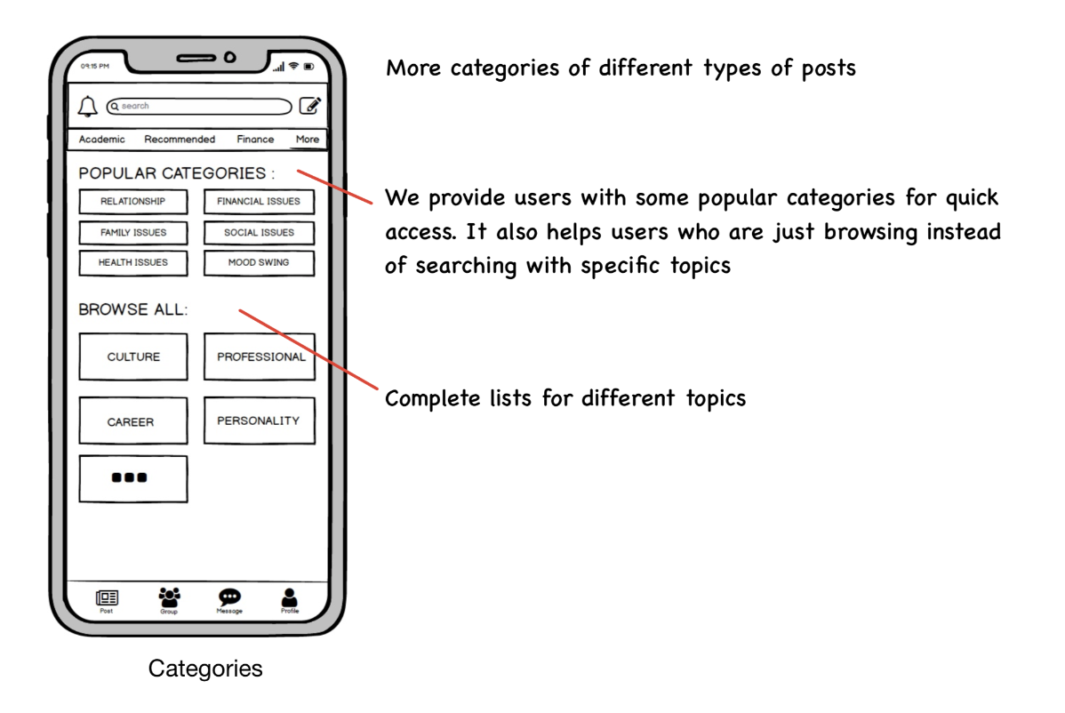

#### 

#### Home Screen (website wireframe example) / Screen 4

Donec nec tincidunt erat, quis gravida justo. Orci varius natoque penatibus et magnis dis parturient montes, nascetur ridiculus mus. Donec facilisis mollis urna, ut volutpat lorem placerat eu. Sed efficitur feugiat lorem, ac mattis nulla posuere vitae. Morbi felis justo, fringilla ac pretium a, tincidunt at tellus. Vivamus risus nisl, maximus quis varius id, rhoncus ut turpis.

Donec nec tincidunt erat, quis gravida justo. Orci varius natoque penatibus et magnis dis parturient montes, nascetur ridiculus mus. Donec facilisis mollis urna, ut volutpat lorem placerat eu. Sed efficitur feugiat lorem, ac mattis nulla posuere vitae. Morbi felis justo, fringilla ac pretium a, tincidunt at tellus. Vivamus risus nisl, maximus quis varius id, rhoncus ut turpis.

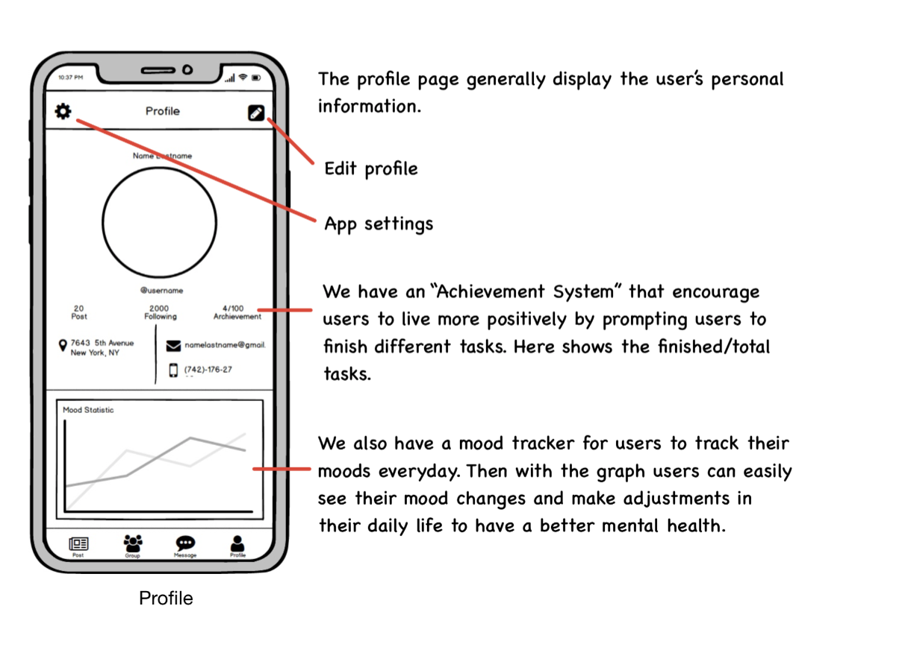

Since this is a draft, we aren’t expecting you provide us with high fidelity screens. However, if you wish to include high-fidelity screens please put them after your low-fidelity screens section.

# Usage Scenarios (~200 words each)

These are short stories about how your personas will use your proposed solution to solve the problems you are trying to solve. Choose two of your personas and describe how each would use your information resource to accomplish their goals. Make reference to your wireframes as you describe the scenarios (e.g., "she then clicks the 'next' link to view the next page of results).

## Usage Scenario 1: Ordering an Uber X Taxi to Fremont Troll

Lorem ipsum dolor sit amet, consectetur adipiscing elit. Phasellus leo mauris, laoreet sit amet nisl vel, commodo condimentum libero. Curabitur bibendum bibendum ex, et auctor arcu laoreet ut. Aliquam a leo et quam luctus lobortis. Aenean venenatis aliquet dui, ut sodales lectus. Pellentesque rutrum eget nibh eu facilisis. Morbi ultricies dapibus eros, egestas varius nisi maximus vitae. Etiam ut tellus nec lorem cursus convallis sit amet quis urna. Curabitur vitae turpis vitae ligula molestie porta nec sed ex. Sed ut est mattis neque aliquet rutrum et sit amet libero. Phasellus ultricies porta viverra. Maecenas a nulla tempor, consequat diam sed, luctus tellus. Sed risus sapien, vehicula sed nisl sed, iaculis scelerisque risus. Pellentesque a rhoncus urna. Ut tincidunt arcu in congue gravida.

Ut mollis dui vitae tortor aliquam feugiat. Morbi aliquet urna sed odio pretium, non fringilla odio suscipit. Mauris lectus nisl, tempus id leo ac, convallis vehicula eros. Nam est mi, iaculis at efficitur sit amet, accumsan ac diam. Nullam ac consequat arcu. Aliquam suscipit euismod neque pharetra consectetur. Phasellus consectetur lectus in pretium pulvinar. Class aptent taciti sociosqu ad litora torquent per conubia nostra, per inceptos himenaeos. Morbi aliquam, tellus at congue elementum, tortor dui gravida lorem, vitae.

## Usage Scenario 2: Scheduling an Uber XL Taxi to the Airport

Lorem ipsum dolor sit amet, consectetur adipiscing elit. Phasellus leo mauris, laoreet sit amet nisl vel, commodo condimentum libero. Curabitur bibendum bibendum ex, et auctor arcu laoreet ut. Aliquam a leo et quam luctus lobortis. Aenean venenatis aliquet dui, ut sodales lectus. Pellentesque rutrum eget nibh eu facilisis. Morbi ultricies dapibus eros, egestas varius nisi maximus vitae. Etiam ut tellus nec lorem cursus convallis sit amet quis urna. Curabitur vitae turpis vitae ligula molestie porta nec sed ex. Sed ut est mattis neque aliquet rutrum et sit amet libero. Phasellus ultricies porta viverra. Maecenas a nulla tempor, consequat diam sed, luctus tellus. Sed risus sapien, vehicula sed nisl sed, iaculis scelerisque risus. Pellentesque a rhoncus urna. Ut tincidunt arcu in congue gravida.

Ut mollis dui vitae tortor aliquam feugiat. Morbi aliquet urna sed odio pretium, non fringilla odio suscipit. Mauris lectus nisl, tempus id leo ac, convallis vehicula eros. Nam est mi, iaculis at efficitur sit amet, accumsan ac diam. Nullam ac consequat arcu. Aliquam suscipit euismod neque pharetra consectetur. Phasellus consectetur lectus in pretium pulvinar. Class aptent taciti sociosqu ad litora torquent per conubia nostra, per inceptos himenaeos. Morbi aliquam, tellus at congue elementum, tortor dui gravida lorem, vitae.

## User Journey Map *(Optional to include)*

In the past, many students have created a user journey map to explain how the user will walk through the solution they have created. This helps you all think about how you wish to structure your final solution. Below is an example of how a user would go grocery shopping for a recipe they wish to cook. You can find a template to help you make a user journey map for your usage scenarios here: <https://dribbble.com/shots/4230991--Free-Template-Journey-Map-Grocery-Shopping>

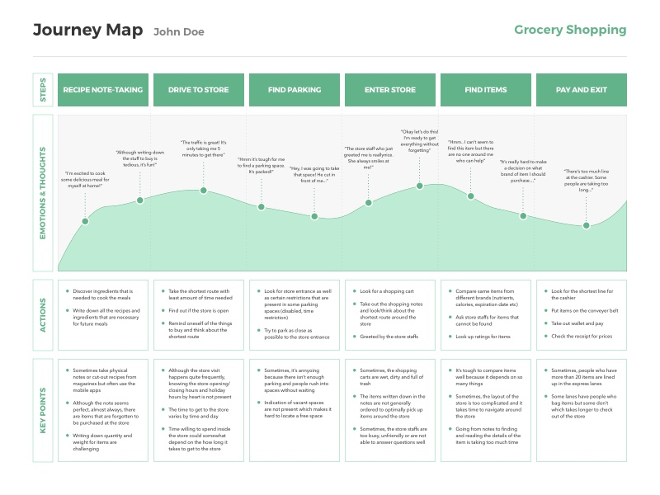

# Bibliography

You may refer to some white paper documents or websites while explaining some of the design decisions you have made. You are required to reference them and provide the citations at the end of the document.

# Appendix

Include any reference images, user research notes, and additional project material in your appendix. The appendix is a great place to include all your project images and scans of your design process.

**Formatting Guidelines:**

* Font: Size 12 - Helvetica, Arial, Roboto, etc.
* Include page numbers in the footer.
* Table of contents
* Margins: Normal - 1 inch
* Caption all images. Provide a figure or label for each.
* Annotate all diagrams and wireframes and provide a legend if necessary
* **SAVE AND SUBMIT THE DOCUMENT AS A PDF.**

**If you are creating a website or an application check out these websites:**

* [material.io/guidelines/](http://s.bl-1.com/h/Z7xJFoh?url=http://material.io/guidelines/): Android Material Design Guidelines
* [https://developer.apple.com/ios/human-interface-guidelines/](http://s.bl-1.com/h/Z7xJKBk?url=https://developer.apple.com/ios/human-interface-guidelines/): iOS Design Guidelines
* [http://findguidelin.es/](http://s.bl-1.com/h/Z7xKpZx?url=http://findguidelin.es/): Brand Guidelines of Popular Tech Companies
* [ui-patterns.com/patterns](http://s.bl-1.com/h/Z7xJQbm?url=http://ui-patterns.com/patterns)
* [Mobile-patterns.com](http://s.bl-1.com/h/Z7xJVzo?url=http://mobile-patterns.com)
* [https://pttrns.com/](http://s.bl-1.com/h/Z7xJZNq?url=https://pttrns.com/)
* [http://mobiledesign.com/](http://s.bl-1.com/h/Z7xKgns?url=http://mobiledesign.com/)
* [https://blog.figma.com/18-designers-predict-ui-ux-trends-for-2018-2d04d41361c6](http://s.bl-1.com/h/Z7xKvyz?url=https://blog.figma.com/18-designers-predict-ui-ux-trends-for-2018-2d04d41361c6)

All the best. That was a lot to read, I know!

Please email your TA if you have any additional questions.